Personal Diving Log

Michael Nelson, USA

PLEASE Call 812 866 3151,

317 396 3158

if found.

Email: Overmyhead@ Aol.com

7-15 July - Staying at CoCo View -Roatan

6 July on AA346

15 July on AA463 #:47 PM

LOG FOR OTHERS.docx

DIRECTIONS TO USE - LOG FOR OTHERS TEMPLATE.DOC

I recommend you keep a copy of this document in addition to your work copy. When working on my diving log, it was often easier easy to go back to a saved copy when my cut-and-paste efforts did not go as planned. Periodically, I would save my work with a different number in case I needed as I built my log.

Periodically you should print a page to ensure margins and all are set correctly. In my log, I never printed on the back of the page because this was an excellent place to keep notes, and I never got it to print correctly.

I have attached the neurological assessment and DCS symptoms documents from DAN in Word format. For my use, I printed this two-page document on 8.5 x 11 paper and inserted in the log

I hope this saves you some labor.

May all your dives have the surfaces you planned,

EQUIPMENT

Shearwater Perdix 2 Computer - Serial #21651AA

Swift AI – Serial #25486

Light stick Battery is A76

Perdix 2 Battery is AA

ScubaPro MK25/ A600 Regulator #

Rebuilt DEC 2023 Adventures Underwater

Adjusting the control knob (clockwise rotation) increases inhalation resistance. Adjusting counterclockwise, reduces inhalation effort. For storage, completely unscrew (counterclockwise) the adjustment knob

The second stage is equipped with a Venturi effect adjustment system, this device must be turned to the minimum (marked “MIN”) or the “PREDIVE” setting while at the surface ERGO lever pointed outward.

At the beginning of the dive the adjustment knob should be turned (lever pointed inward) to the “MAX” or “DIVE” position.

Casio Watch MVD #2384

DGX Light #20782162

DGX Video #2056831

BC is Sea Quest Black Diamond

GoPro Hero5 #3161326555904

**OC WEIGHTS SALT**

Steel 100Ft- 10lbs, shorty & 3mm **Heavy, try 8**

Steel LP 85 – 8 lbs. WS/cap, perfect down to 1600 lbs.

AL80, Zeagle BC, skin, cap, 3MM,Roatan 2022 2 2

5 5

Satoshi Nakamoto , AL80 skin, Roatan 2021, light, 3 3

6 6

**OC WEIGHTS FRESH**

AL 80-tanks 12 lbs, 3mm WS (two dive lights), TRY

Steel 85 - 4 lbs, 3mm WS, (two dive lights), Try +2lbs

Steel 100, 0 , 3mmWS, cap (two dive lights)

Steel 100, 8lbs, 7mm WS, cap (one dive light) No skin 0 0

4 4

Prescriptions are: One martini a day

One cigarette after lunch

Telephone numbers:

Braniff Airlines credit card, 568.254.2255

Trans American Airline, 630-531-6632

American Consulate - Philippines, 2.555.231.2552

Joe’s Travel, 654-528-7719

GOPRO Camera

Camera wiggles in mount when an underwater still is taken. Best to take movie and pull still.

4-16850, light runs 18 minutes at ¾ charge; too bright on high for 4 feet away.

Take picture of from of logbook before you enter the water so if camera is lost the finder has my contact information.

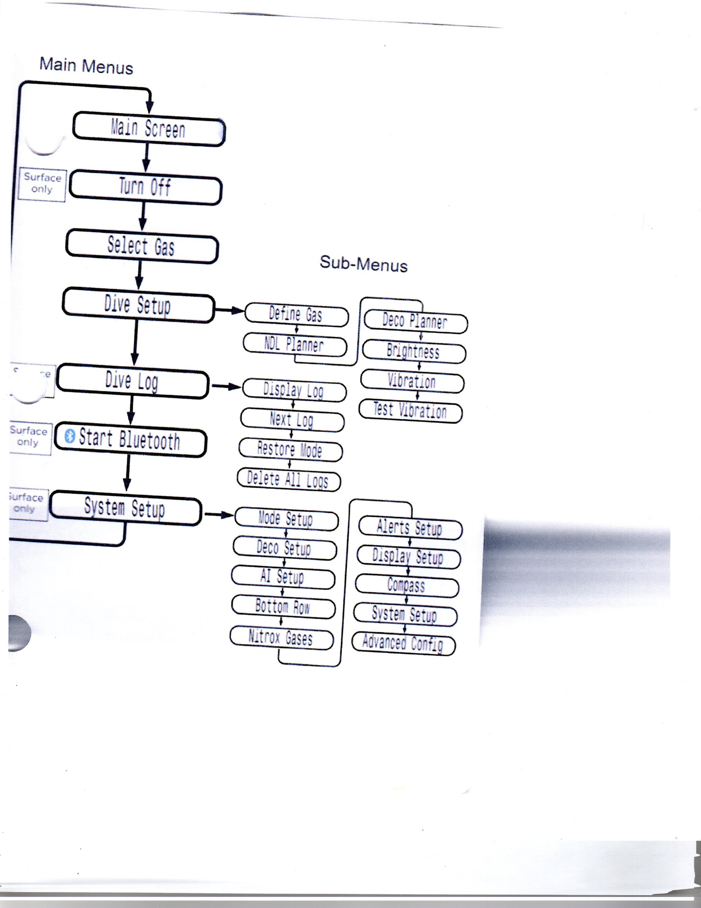

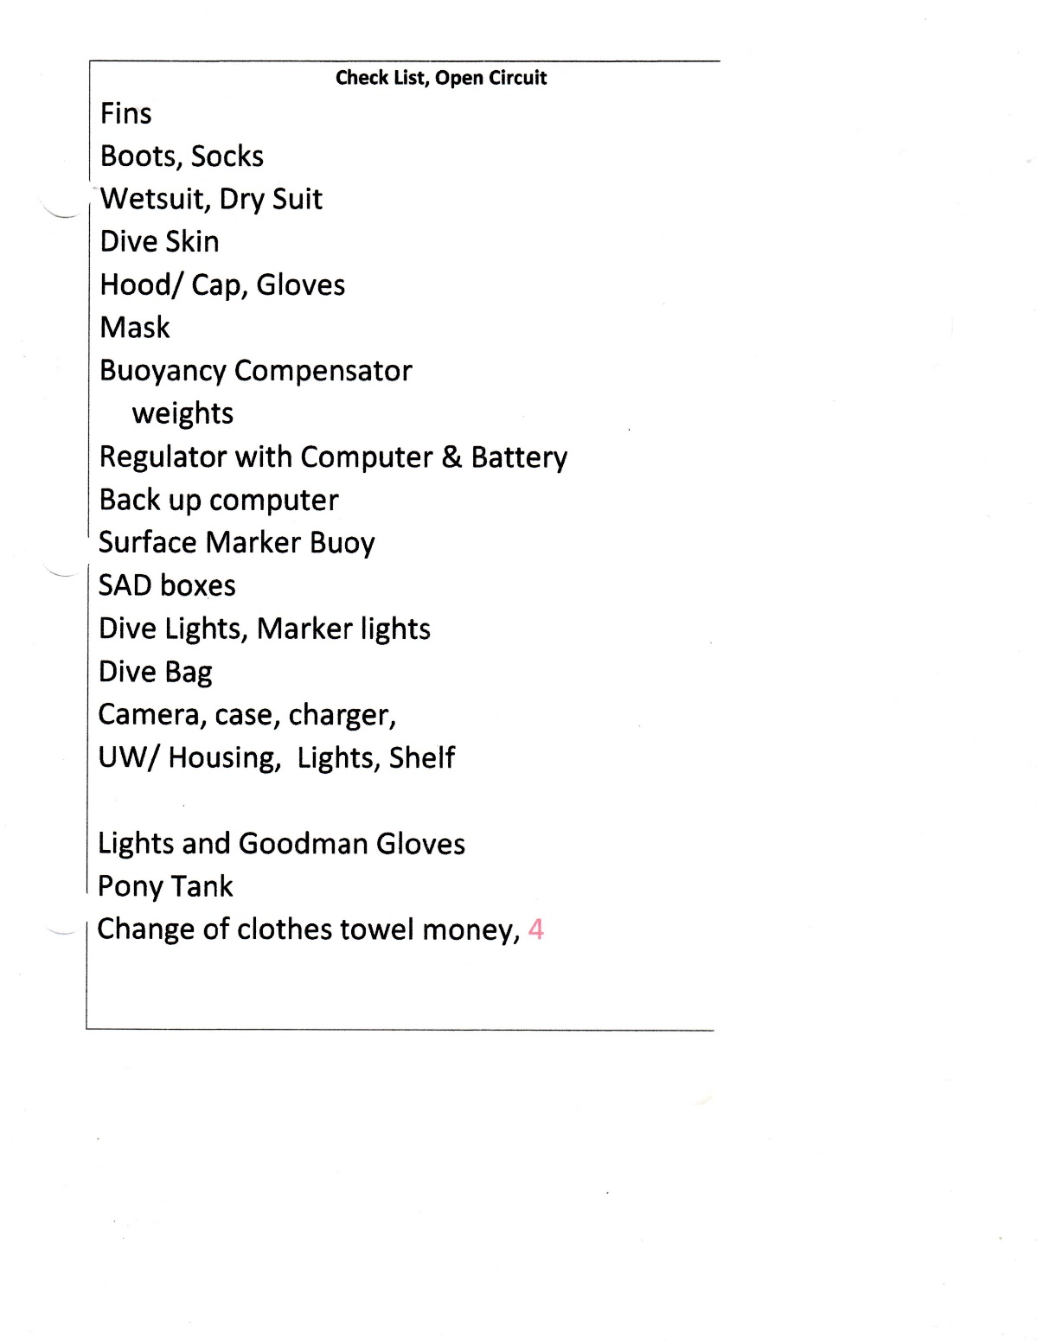

Consider:

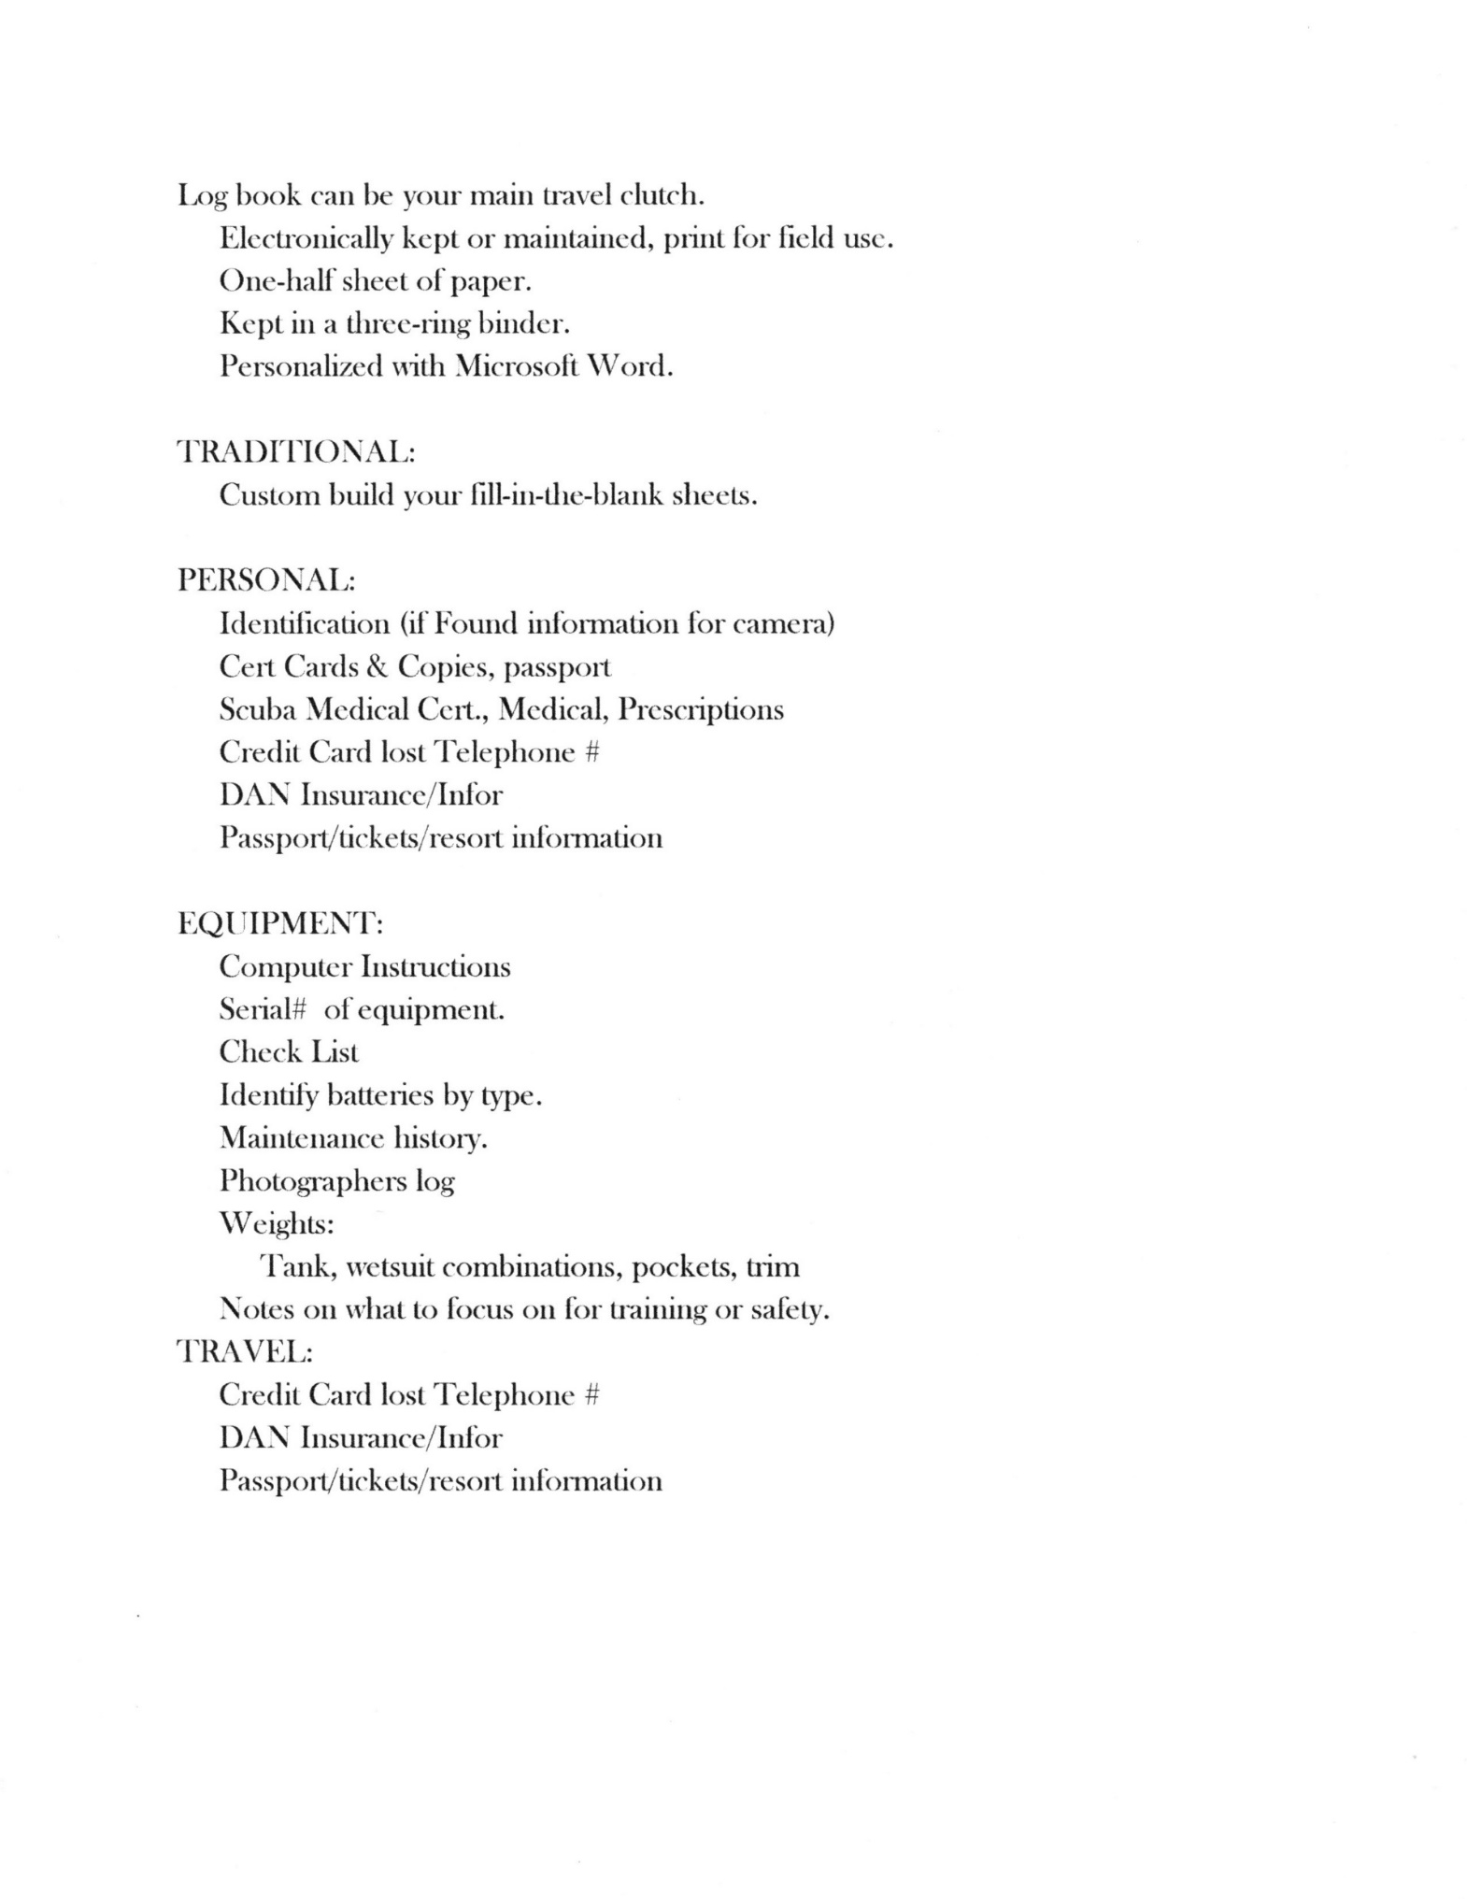

**Dive Site:**  **#Dives 321/ 4**  **04/00/2022**

Location:

DC Model: Wisdom 4 computer shows 24 tot in history

Time in: Time out:

Prior SI:

Max Depth: ft. AV Min. Temp: °

Cylinder: AL 80 FO: Air/Nitrox

Dive Time: mins. Average Depth: FT.

Start Pressure: PSI. End Pressure: PSI. FO2: SAC Rate: Ft3/min.

Bar Segments:

NiBG: O2BG: / PO2: ASCENT: >5

**Comments:**

COPY AND PASTE

USE AS A TEMPLATE

Date: 2 of 2

COPY AND PASTE

USE AS A TEMPLATE

**Dive Site:** 4th Window & Flower Garden **#Dives 414/ 2**   **04/22/2024**

**Total / This trip**

Location: Rivera Beach, FL W/ Kyalami Charters

DC Model: Shearwater Perdix 2/ Swift AI

Time in: Time out:

Prior SI:

Max Depth: ft. AV Min. Temp: 75°

Cylinder: AL 80 FO: 35% Nitrox

Dive Time: mins. Average Depth: FT.

Start Pressure: PSI. End Pressure: PSI. FO2: SAC Rate: 17.69 psi/min.

Bar Segments:

**Comments:**

It has been 88 days since the last dive. I dove SP Hydros Pro BCD for the first time. I thought I used 14 lbs, but the weight lacked easily readable numbers and I was significantly heavy.

The computer lost communication with the sending unit twice but seemed okay at the end of the second dive.

I concentrated on shooting GoPro pictures, so 59 minute dive had me down to 490 psi. SAC Rate was 19.47 then 17.92 on next dive both with AL80s.

Dove with Villages Dive Club who posted on the website “We had great conditions: 1 Foot waves, 8-9 second Wave Interval, and Fair Skies. The Water Temp was 75 Degrees. Visibility was ~40 feet on the first dive and 30-35 or less on the second dive.

We literally dropped in on a large Loggerhead Turtle who appeared to be totally unconcerned by our appearance. In addition, we saw multiple Green and Speckled Moray Eels, a large school of Spadefish, Porcupinefish, and the usual rich mix of Angelfish, Grunts, Tomtate, Porkfish, Butterflyfish, Trunkfish, Etc.

**Dive Site:** CoCo View Resort  **#Dives 410/ 16** **9-15 DEC 2023**

**Total / This trip**

Location: Roatan Honduras

DC Model: Shearwater Perdix 2/ Swift AI

Max Depth: 90ft.

Cylinder: AL 80 FO: Nitrox 30%

**Comments:**

This sheet summarizes my trip to Roatan, Honduras, 9-15 December 2023 with The Villages Dive Club.

I paid an additional $150 for Nitrox and was disappointed that it usually tested to be **29.5%.** I never asked, but I assumed it would be 32%. We were on vessel Coco View II, which had a center trunk for divers to reboard in bad weather and a walk-through stern. They are the easiest dive boats I have ever used. The service was outstanding. We just analyzed our tanks and left them next to our gear, and the crew had our regulators and BC’s hooked up when we arrived for the dive. New to the resort, divers had a checkup dive in front of the resort with a wreck in 35 feet of water and some nice reefs. They had an excellent free buoyancy and trim class. When a diver asked me what trim is and if they should attend the class, I smiled and said they should, and then they would know what trim is. There was also a free photography class.

I opted not to go on a shark dive but will in the future because those who did said it was great. We had three days of rainy weather, and the gray skies killed the color and photographs without artificial light. The resort offered few clean and disinfected customers’ gear. No one thought it was worth the money and they were disappointed that the gear was not dried. I was diving a Mark 25/A600 regulator with Shearwater air integration and it worked flawlessly. My buoyancy was good at 14 pounds but I needed to loosen the indexing strap so the tank would rise higher in my BC for optimum trim. Now comfortable with the straps, I can lift them so I am slightly head down when I take pictures.

Date: **09/12/2022,** 2 of 3

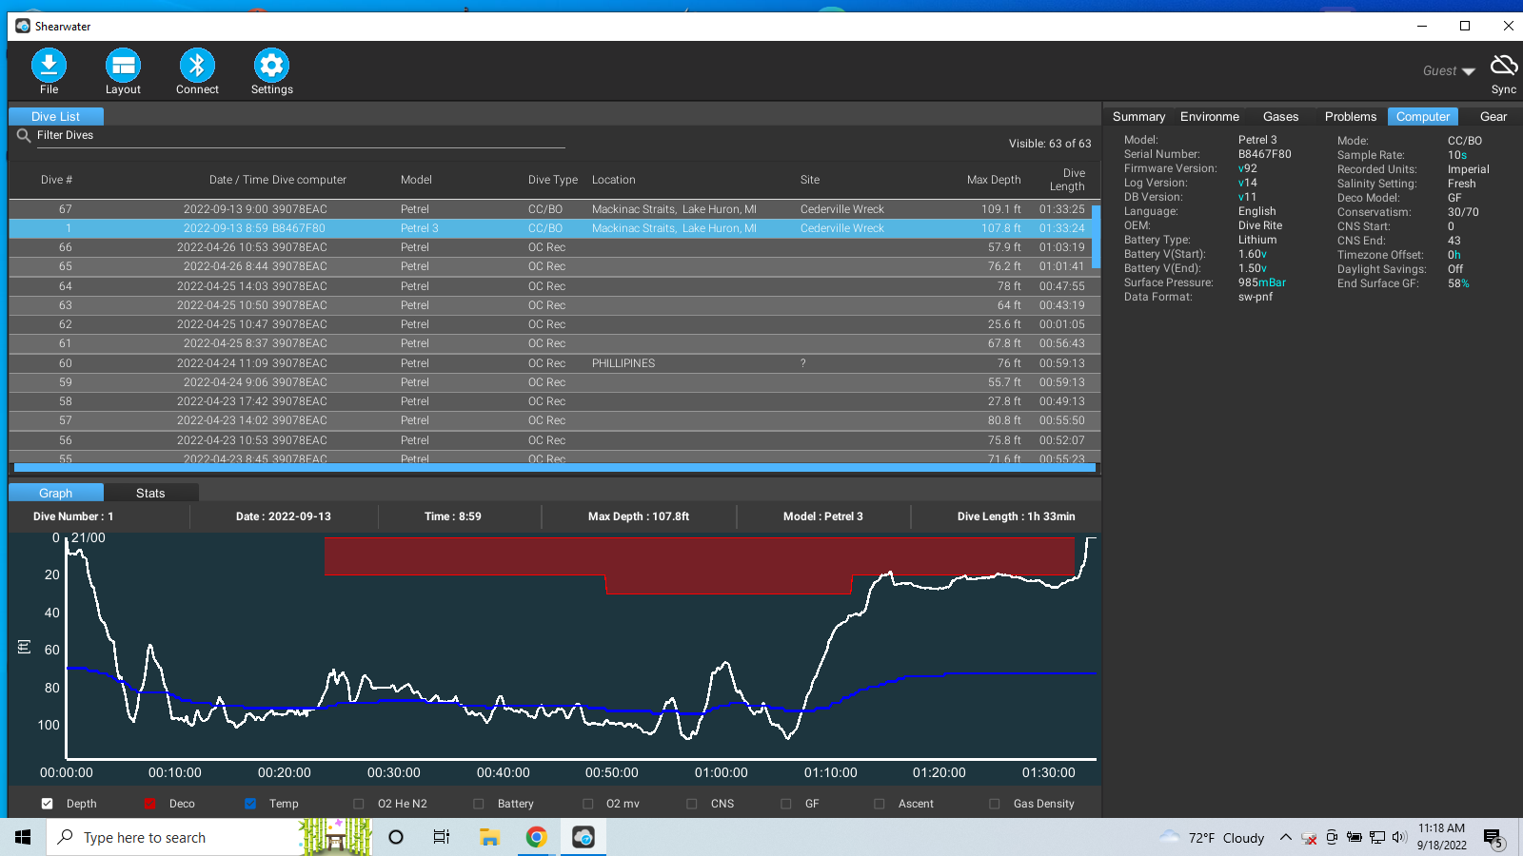

Shearwater Cloud log (above) is great!

This was my third decompression dive.

The Petrel 3 guided me through decompression. The slow ascent from 109 and the stop at 40 ft for the 30ft deco stop, reduced time from the directed 20 minutes at 20ft. stop. I did most 20ft. deco at 25 feet because I received a yellow warning and I think vibration when I went to 17ft. Was above stop less than a minute. Manually increased PPO2 to 1.3+- at stop. Did not change PPO2 to .6 after deco.

We came up on the wrong buoy, at the wrong end of the vessel. Boat crew said we were very low in water and were glad we deployed SMBs. A blinking light would have been useful.

**Dive Site:**  **#Dives 321/ 4**  **04/00/2022**

Location:

DC Model: Wisdom 4 computer shows 24 tot in history

Time in: Time out:

Prior SI:

Max Depth: ft. AV Min. Temp: °

Cylinder: AL 80 FO: Air/Nitrox

Dive Time: mins. Average Depth: FT.

Start Pressure: PSI. End Pressure: PSI. FO2: SAC Rate: Ft3/min.

Bar Segments:

NiBG: O2BG: / PO2: ASCENT: >5

**Comments:**

COPY AND PASTE

USE AS A TEMPLATE

COPY AND PASTE

USE AS A TEMPLATE